Name: Bryan Orville Audric

NIM: 2602160750

No 1

Print Before Inserting [E, I, L, G, X]

Print After Inserting [E, I, L, G, X]

After Deleting O

After Deleting T

After Deleting D

After Deleting P

After Deleting X

After Deleting S

After Deleting I

After Deleting C

After Deleting M

After Deleting K

After Deleting E

No 2  
After Inserting 41, 22, 5, 51, 48, 29,18, 21, 45, 3

No 3

After Inserting 6

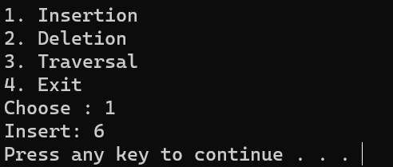

After Inserting 27

After Inserting 19

After Inserting 11

After Inserting 36

After Inserting 14

After Inserting 81

After Inserting 63

After Inserting 75

Displaying Data

After Deleting 14

After Deleting 75

After Deleting 36

After Deleting 19

After Deleting 11

